Forage Quantity and Protein Concentration Changes Across a Forest-Savanna Gradient with Management Implications for White-Tailed Deer

**C. M. McKinneya*, R.E. Mastersb, A. Adhikaria, B. Mishraa O. Joshia, Chris B. Zoua, Rodney E. Willa**

aDepartment of Natural Resources Ecology and Management, 008C Agricultural Hall, Oklahoma State University, Stillwater, OK 74078, USA

, bCollege of Natural Resources, University of Wisconsin-Stevens Point, Stevens Point, WI 54481, USA

*Corresponding author

E-mail address: caleb.mckinney@students.tamuk.edu (C.M Mckinney).

**Highlights**

**•Management of forests for multiple objectives including wildlife is increasingly important.**

**•Forest thinning and prescribed fire impact the production and nutrient concentration of understory plants**

**•The effects of forest management on deer forage are greatest when deer are most in need of nutrient rich forages**

**ABSTRACT** White-tailed deer (*Odocoileus virginiaus*) hunting is an important economic activity associated with the management of forests and rangelands in the USA, with over 12.9 billion dollars of related annual expenditures. Reducing tree cover through thinning and prescribed fire both have the potential to increase the quantity and quality of deer forage. We evaluated the long-term impacts of eight different combinations of fire return intervals and tree harvest on three major aspects of deer forage – forage productivity, timing of forage availability, and protein content of the forage. Based on management regime, study units ranged from savanna to closed-canopy forest. Aboveground net primary production (ANPP) of six functional groups (grass, panicum, forb, legume, woody, sedge) of understory vegetation was measured in October 2019 and 2020 using destructive sampling. Percent cover of vegetation functional groups was measured monthly from March through October 2019 and 2020. Samples for foliar crude protein (CP) concentration were collected in spring, summer, and fall of 2020. Total understory ANPP ranged from 2.9 to 466.3 g m-2 and was up to 566% greater in savanna systems maintained by frequent fire (return interval of three years or less) than in non-burned forest treatments. Annual burning resulted in ANPP dominated by herbaceous plants composed mostly of fire-tolerant C4 grasses (e.g., *Andropogon gerardii , Schizachyrium scoparium.*) Longer fire return intervals or no fire resulted in roughly equal ANPP from understory woody and herbaceous species. Coverage of most functional groups reached a maximum in mid-summer, then plateaued or declined slightly in the fall. The exception was forb coverage which peaked in April and had very little coverage in summer and fall, indicating a potentially important source of forage early in the growing season. Crude protein concentrations were up to 45.7% greater in the woodland and forest units than in the savanna units for seven of the eleven species sampled. The greater CP in the forests was most noticeable in the summer when deer needs for quality forage are substantial. Increased protein concentrations of understory species in the forests, but greater ANPP in the savannas indicate that managing for a mix of savanna and woodland could be ideal for balancing forage quantity with increased forage protein.

**KEY WORDS** crude protein, nutrition, *Odocoileus virginiana*, Oklahoma, prescribed fire, savanna,wildlife, understory productivity

**1. Introduction**

Managing forests for multiple objectives, including wildlife habitat, has the potential to achieve the varied goals of landowners and increase the economic viability of forested habitats (Grado et al. 2001), especially where productivity is lower or plantation forestry is not preferred. In addition, expected increases in temperature and variability of rainfall under a changing climate may decrease viability of traditional timber management, especially in areas where precipitation is marginal (Will et al. 2015, Reidmiller et al. 2018). In particular, management for wildlife is important to the family forest owners who control greater than 30% of forestland in the USA. A recent nationwide survey found 73% of family forest owners list wildlife as a reason for owning forestland, found that the most frequent form of recreation was hunting (70%), and found the family forest owners do more active management for wildlife than timber (Butler et al. 2021).

The understory, i.e., herbaceous vegetation and short-stature woody plants, is often overlooked in forest management, but often supports the majority of plant biodiversity (e.g., Gilliam 2007) and provides habitat components for wildlife. Increased understory productivity has the potential to improve habitat for many wildlife species including economically important game species like white-tailed deer (*Odocoileus virginianus*), wild turkey (*Meleagris gallopavo*), and northern bobwhite (*Colinus virginianus*) (Wilson et al. 1995, Masters et al. 1998, Howze and Smith 2021). Understory aboveground net primary production (ANPP) increases as overstory canopy cover decreases (e.g., Feltrin et al. 2016). In particular, prescribed fire serves an important role for the understory as it helps maintain open canopy structures, removes litter to provide a suitable substrate for seed germination and growth, and has direct positive impacts on plant diversity (Platt et al. 2006) and understory ANPP (Masters 1991, Masters et al. 1993, Reich et al. 2001, Feltrin et al. 2016, Adhikari et al. 2021a).

White-tailed deer (hereafter deer) are the most sought-after game species in North America with nearly 11 million deer hunters (Fuller 2016) spending 12.9 billion per year in the USA (DOI 2017). Deer and deer hunting, therefore, are an important cultural and economic resource associated with the management of forests. Management of woodlands and forests in the southeastern USA for deer often involves increasing the availability of forages by producing and maintaining early successional habitat through timber harvesting, prescribed fire, or a combination of these treatments (Masters et al. 1993, Lashley et al. 2011, Glow et al. 2019). However, in forests not managed for deer, habitat is often marginal because of limited understory biomass production resulting from a dense, often multi-layered tree canopy (Masters et al. 1993, Sparks et al. 1998).

Deer diet composition usually consists of a variety of forbs, legumes, woody browse, and hard and soft mast with significant seasonal variation (Jenks 1991, Johnson et al. 1995, Gee et al. 1994). While grass is not preferred, deer will consume tender sprouts shortly after spring green-up especially at burned sites (Stransky and Harlow 1981, Lewis et al. 1982, Masters et al. 1993). In contrast, woody browse is the largest component of deer forage and is consumed throughout the year (Short 1971, Johnson et al. 1995, Jenks et al. 1991, Gee et al. 1994). Nutrient demands for deer vary greatly throughout the year and among different age and sex classes. A basic maintenance diet for an adult deer contains around 6-10% crude protein (CP) (French et al. 1956, Holter et al. 1979, Asleson et al. 1996, National Research Council 2007). Protein demands are greater at many key life stages for deer including, 14-22% for fawns (Ullrey et al. 1967), 11% for yearling deer (Holter et al. 1979), 11-12% for antler growth (Asleson et al. 1996), and 14% for lactating females (Jones et al. 2009, Lashley et al. 2011, Hewitt 2011). While CP is only one measure of forage quality for deer, it is easily interpreted, well-studied, and correlates well with the key life history processes listed above.

The purpose of this study was to quantify deer forage quality and productivity across a wide range of ecosystem types in an experimental setting. Experimental units, which ranged from forest to grassland, were created by various combinations of tree harvest, chemical thinning, and prescribed fire. The objectives were to 1) Compare understory ANPP of eight treatments representing different management regimes that created conditions ranging from grassland to closed-canopy forest, 2) Compare changes in the understory vegetation community throughout the growing season, and 3) Track changes in forage CP concentration throughout the growing season, and between treatments. Our results further our understanding of how forest structure and management affect the quality of deer habitat and help natural resource managers make informed decisions to meet landowner goals that include wildlife.

**2. Materials and Methods**

*2.1 Study area*

This study was conducted at the Pushmataha Forest Habitat Research Area (FHRA; 34◦31′40′′ N, 95◦21′10′′ W), established in 1983 to study the effects of different treatments involving tree harvesting and chemical thinning combined with different prescribed fire return intervals to create and maintain early successional environments (Masters 1991, Masters et al. 1993b). The FHRA comprises 53 ha of the 7690 ha Pushmataha Wildlife Management Area (PWMA), which is owned and managed by the Oklahoma Department of Wildlife Conservation (ODWC). The FHRA is located in the Kiamichi Mountains in southeastern Oklahoma at an elevation of 320-340 m above sea level. Soils in the area are an association of the Caransaw (fine, mixed, semiactive, thermic Typic Hapludults) and Stapp (Fine, mixed, active, thermic Aquic Hapludults) soil series, and are shallow and rocky with slopes ranging from 8-12% (Masters et al. 1993a, b). The climate is semi-humid to humid with hot summers and mild winters. The mean annual precipitation and temperature in the area from 1986 to 2016 were 1212 mm and 17.5 oC, respectively (Oklahoma Climatological Survey). The growing season averaged around 210 days for the last 30 years with the average first freeze occurring near the end of October.

The PWMA is located near the western edge of the southern oak-pine forest (Duck and Fletcher 1943). In areas that have not been thinned and burned, a closed-canopy forest dominated, approximately 100-years-old (Adhikari et al. 2021b), composed primarily of shortleaf pine (*Pinus echinata*), post oak (*Quercus stellata*), and hickory *(Carya* spp*.)*. In this condition, there was little understory vegetation. However, there were sparse areas of shade-tolerant plants such as greenbriar (*Smilax spp.),* poison ivy *(Toxicodendron radicans)*, grape (*Vitis* spp*.),* andsedges (*Carex* spp*.*). In burned areas, shortleaf pine and post oak also dominated the overstory, but hickory was less common. In more open areas, understory of burned units was mainly composed of tallgrass prairie species such as big bluestem (*Andropogon gerardii)*, little bluestem (*Schizachyrium scoparium)*, and Indiangrass (*Sorghastrum nutans*), with some mostly cool season *Panicum* and *Dichanthelium* spp. Common native forbs and legumes included slender lespedeza (*Lespedeza virginica*), *Desmodium* spp*.*, showy partridge pea (*Chamaecrista fasciculata*), trailing wildbean (*Strophostyles helvola),* elm-leaf goldenrod (*Solidago ulmifolia*)*,* button snake-root (*Eryngium yuccifolium),* and hairy sunflower (*Helianthus hirsutus*). In annually burned areas, the invasive sericea lespedeza (*Lespedeza cuneata*) was common. In areas with 2 to 4-year fire return intervals, understory woody plants included resprouting oaks and hickories, winged sumac (*Rhus copallinum*), American beautyberry(*Callicarpa americana),* and winged elm (*Ulmus alata*).

*2.2 Treatments*

In 1983, 28 (0.8 to 1.6 ha) experimental units were established in a randomized design (Masters 1991). Treatments were applied in 1984. The FHRA site had eight treatments with three replications of each treatment, except for HT3, which had two replicates. The treatments consisted of different combinations of harvesting (H) shortleaf pine trees greater than 11.4 cm diameter at breast height (DBH = 1.4 m), thinning (T) of hardwoods to a basal area of approximately 9 m2 ha-1 using single stem injection of herbicide, and fire return interval (1–4 years as well as no fire). Six of the eight treatments were named according the application of H, T, and fire return interval. The treatment designated HNT1 had pine harvested, but did not have hardwoods thinned (no thin, NT). The other two treatments were RRB (rough reduction burn) with fire every four-years but no harvesting or thinning of trees, and CONT (Control) with no thinning, harvesting, or burning (**Table 1**). Fires (dormant-season burns; January through March) were initiated on selected units in 1985, using strip headfires and maintained through the duration of the study. However, in 1995 the 1- and 2-year interval treatments were not burned. Data for this study were collected in 2019 and 2020. In 2019 and 2020, the HT1 and HNT1 (annual burn) treatments were burned. In 2019, the HT2 treatment units were burned. The HT3 units were burned in 2018 and the HT4 and RRB treatments were burned in 2017. Therefore 2020 data represent all burn treatments at their maximum extent for time since burned.

*2.3 Aboveground net primary productivity methods*

Understory ANPP was measured using clip plots between 7-12 October 2019 and 16-20 October 2020. Aboveground vegetation was clipped from 0.25 m2 (0.5 × 0.5 m) quadrats along two randomly located transects per unit. Ten plots from each treatment unit were sampled in 2019 and, due to covid-19 related travel restrictions reducing available labor, six plots per unit in 2020. Only current-year leaves and shoots of woody vegetation below 1.4 m in height were clipped. In addition, litter that consisted of dead herbaceous material, leaves, and branches (< 2 cm diameter) was collected from each plot. Understory vegetation was separated into the following functional groups: woody, panicum grasses, (C4) grasses, non-legume forb, sedge, and legume. The samples for each plot and functional group were kept separate and dried at 60°C to a constant mass. All samples were collected before first frost. October was chosen as the month to sample ANPP as it represents the maximum standing forb and grass biomass in the region (Blair et al. 1977). While there was no livestock grazing in the FHRA, wildlife herbivory might have reduced understory biomass before sampling. However, herbivore exclusion studies at the site (Masters et al. 1993a) found that herbivory had little effect on understory biomass estimates.

*2.4 Percent cover methods*

During 2019 and 2020, the understory percent cover of plant functional groups for each experimental unit in the study area was visually estimated with a standard 20 × 50 cm Daubenmire frame (Daubenmire 1959). Percent cover sampling was conducted along the two previously established 100 m transects in each unit (Masters 1991a, b). Ten samples were taken along each transect at random intervals for a total of 20 sampling points for each unit on each sampling date. Data were collected monthly during the growing season (March-October) and once during the dormant season to capture seasonal changes in plant communities that make up important components of deer forage. The same transects were used each sampling period, but the individual frame locations were at different points each month. When conducting the Daubenmire sampling, ground cover was separated into the following functional groups: woody, panicum grasses, C4 grasses, non-legume forb, sedge, legume, litter, bare ground, and rock. Only understory woody vegetation less than 1.4 m in height was sampled. The functional groups were estimated using the following eight categories (0.01<1.5%, 1.5<3.5%, 3.5<7.5, 7.5<17.5%, 17.5<37.5%, 37.5<62.5%, 62.5<85%, 85<97.5%) that covered a range of percentages, and the midpoint of each class was used for analysis.

*2.5 Crude protein methods*

Foliar crude protein (CP) concentration (total nitrogen concentration × 6.25) of selected forage plants was measured three times during the 2020 growing season, 15-18 April, 6-10 July, and 19-23 October. The following eleven deer forage species were sampled: big bluestem, openflower rosette grass (*Panicum laxiflorium*), winged elm, post oak, winged sumac, greenbriar (*Smilax bona-nox*), American beautyberry, slender lespedeza, serecia lespedeza, showy partridge pea, and *Desmodium spp*. Samples were collected from HT1, HT2, HT3, HT4, RRB, and CONT treatments.

Plants growing at least 19.8 m inside from the edge of a unit were sampled to reduce edge effects from adjacent units (Masters 1993a). Fresh current-year growth was sampled mimicking herbivory by a concentrate selecting ruminant (Lashley et al. 2014). For woody species, the terminal 2 cm of a twig and any leaves associated with that bud were collected. For herbaceous plants, the terminal 20% of healthy-looking plants were collected. Samples were collected from 10+ individuals per unit when possible. While species were selected that occurred across the spectrum of treatments, the legumes (showy partridge pea and both lespedeza species), along with winged sumac did not occur in all replications of the CONT treatment. Also, the legumes were absent from most treatments for the early spring sampling so they were dropped from the analysis for that sampling period.

All plant material was refrigerated after collection until they could be processed and oven dried. All forage samples were analyzed at the Soil, Water, and Forage Analytical Laboratory (SWFAL) at Oklahoma State University. Samples were first dried for 12 hours at 85 °C and then ground to pass through a 1.0 mm screen. For CP, total nitrogen (TN) was determined using a Leco (St. Joseph, Michigan) CN628 dry combustion Carbon/Nitrogen Analyzer (NFTA, 1993).

*2.6 Data analysis*

All data were analyzed with SAS 9.4 (SAS Institute Inc. 2013) PROC MIXED procedure. For ANPP, all quadrats within each unit were averaged to calculate a unit mean for each of the six functional groups. The unit means were log transformed prior to analysis. Data presented in figures and tables are shown as non-transformed data. Total ANPP was analyzed as well as each functional group separately. When a significant difference occurred (p <0.05), means separation was performed using the “pdiff function” to determine which treatments significantly differed from one another. Data from 2019 and 2020 were analyzed separately.

For percent cover analysis, the 20 frame samples collected each month were averaged to calculate the monthly unit means for each functional group. The unit means were then arcsine transformed prior to analysis. Data from 2019 and 2020 were analyzed separately. To compare whether monthly trends in coverage of plant functional group differed among treatments, a repeated measures analysis using an autoregressive covariance structure (AR1) was conducted incorporating month of sampling. Each functional group was analyzed separately. For treatments where monthly trends differed among treatments, i.e., a significant month*treatment interaction, an analysis was conducted using the “pdiff” function to determine which months the treatments significantly differed from one another (P < 0.05).

To compare whether seasonal trends in CP concentration differed among treatments, a repeated measures analysis was conducted using season of sampling as the repeated factor with an autoregressive covariance structure (AR1). Each species was analyzed separately. For species with a significant season*treatment interaction, means separation was conducted using the “pdiff” function to determine which seasons the treatments significantly differed from one another.

**3. RESULTS**

*3.1 Aboveground net primary productivity*

Measured one year after establishment in 1985, all treatment units that received the H and T treatments were similar, averaging 4.0±0.53 m2 ha-1 (mean ± SE) basal area (BA) and 9.7±2.42% canopy cover while the non-thinned CONT and RRB averaged 26±0.67 m2 ha-1 BA and 72±2.3% canopy cover (Masters et al. 1993). When measured in 2017, the HT and HT4 treatments as well as the CONT and RRB treatments were classified as forests (basal areas greater than 18.4 m2 ha-1; Dey et al. 2017) because no fire (HT) or fire every four years (HT4), resulted in a large increase in overstory. Among the forest treatments, the non-burned HT and CONT had greater BA and canopy closure than burned units, i.e., HT4 and RRB (**Table 1**). The remaining treatments were classified as savanna in 2017. Among the savanna treatments, the HT1 had the lowest canopy cover and its structure was more similar to grassland while the other savanna treatments (**Table 1**) had BA and canopy cover near the maximum limits for savanna, e.g., BA < 7 m2 ha-1 or <30% canopy closure (Dey et al. 2017).

In 2019, total understory ANPP was up to 566% greater in the savanna treatments (HT1, HT2, HT3, HNT1) than in the forest structured treatments (HT4, HT, RRB, CONT) (**Figure 1**). The savanna treatments, HT1 and HT2 in particular, had the greatest ANPP with over 450 g m-2. The other two savanna treatments HT3 and HNT1 had just over 300 g m-2 of ANPP and were statistically similar to other savanna treatments as well as the most productive forest treatment (HT4). There was considerable variation (18.3 to 149.6 g m-2)among the forest treatments with lower values for treatments that were not burned. However, the forested treatments were statistically similar (P > 0.05) given large within-treatment variation. Results were similar in 2020, except the HT1 treatment had greater ANPP than all other treatments. Compared to 2019, ANPP of the HT2 treatment declined by 40% in 2020 (second year after burning), whereas the other treatments declined by an average of 15.2%. In general, treatments with annual burning were dominated by herbaceous vegetation, treatments with fire intervals of 2-4 years had more equal proportions of herbaceous and woody ANPP, and non-burned treatments were dominated by woody ANPP.

Among the herbaceous components, C4 grass was the largest contributor to ANPP for most treatments in both years. In 2019, grass ANPP ranged from 1.5 g m-2 in the HT treatment to 341.9 g m-2 in the HT1 treatment (**Table 2**). C4 grass ANPP for the HT1 treatment was significantly greater than the HT3 and forested treatments (i.e., HT, CONT, RRB, and HT4), the HNT1 and HT2 treatments were greater than the forested treatments, and the HT3 treatment was greater than the HT and CONT treatments. C4 grass ANPP was less for most treatments in 2020 ranging from 292.3 g m-2 in the HT1 treatment to 0.1 g m-2 in the HT treatment (**Table 2**). Trends and significance among treatments were generally similar in 2020 with the exception that grass ANPP of HT1 treatment was greater than all other treatments. In 2019, legume ANPP ranged from 54.7 g m-2 in the HT1 treatment to 0.1 g m-2 in the HT treatment (**Table 2**). In 2019, legume ANPP of the savanna treatments were statistically similar, but the HT1 treatment was greater than the forested treatments, the HNT1 was greater than the CONT and HT treatments, and the HT2 treatment was greater than the HT treatment. In 2020, legume ANPP was a smaller component for all treatments except for the HT1 treatment, which had 46.1 g m-2 and was significantly greater than the other treatments (**Table 2**).

In 2019, woody ANPP ranged from 169.6 g m-2 in the HT2 treatment to 10.3 g m2 in the HT treatment, and in 2020 ranged from 137.6 g m-2 in the HT3 treatment to 0.7 g m-2 in the HT treatment. Despite the wide range in woody ANPP, no significant differences were found due to high within-treatment variation. In both years, forb ANPP was significantly greater in the annually burned HNT1 (2019) and HT1 (2020) than the other treatments, where it was less than 1.5 g m-2 in 2019 and 4.5 g m-2 in 2020 respectively. Panicum grasses and sedges were a small contributor to ANPP for both years and not significantly different among treatments, except for sedges in 2019 (**Table 2**).

*3.2 Percent cover*

For percent cover, all functional groups showed significant treatment differences (P < 0.05) except sedge in 2019 (**Table 3**). However, the treatment effects were not consistent for all sampling periods. There were significant interactions between treatment and month for grass and legumes in 2019 (P <0.0001) and 2020 (P = 0.0001), for panicum in 2019 (P < 0.0001), and for woody in 2020 (P = 0.023). These interactions occurred primarily because all treatments had similarly low coverage in the dormant-season and early spring samplings, and then coverage diverged during the middle of the growing-season (**Figure 2**). As treatments were largely consistent in rank during the growing season, main effects are discussed below. However, treatments burned before a given growing season (HNT1 and HT1 both years, and HT2 in 2019) maintained greater grass coverage into the fall when compared to non-burned treatments.

Average coverage of C4 grasses was greatest (P<0.05) in the savanna treatments (HNT1, HT1, HT2, HT3) with 41.9% to 50% in 2019 and 24.1% to 39.7% in 2020 (**Table 4**). However, coverage in the HT3 treatment was lower than annual burn treatments in 2020. In 2019, grass coverage in the HT4 treatment was greater than all other forest treatments at 21.5%. The coverage of the RRB treatment, 12.1%, was greater than the non-burned CONT and HT treatments, 1.4% and 0.5% respectively. In 2020, grass coverage of the HT4 (13.3%) and RRB (10.7%) were similar, but greater than the HT and CONT treatments both with less than 1% coverage.

Woody plant coverage had the second greatest percent coverage among functional group for most treatments ranging from 2.6% to 9.6% in 2019 and 1.5% to 13.6% in 2020 (**Table 4**). Woody plant coverage was significantly greater in treatments with longer fire return intervals (HT2, HT3, HT4, and RRB), and declined with annual burning or in the absence of burning. Woody coverage was greater for most treatments in 2020 than in 2019. In 2019, forb coverage ranged from 3.8% in the HNT1 treatment and 0.3% in the HT treatment (**Table 4**). Coverage was the greatest in treatments burned that year (HNT1, HT1, HT2) and RRB. Forb coverage was the lowest in HT along with CONT and HT3 treatments. In 2020, forb coverage ranged from 2.3% in the RRB treatment to 0.1% in the HT.

In 2019, legumes ranged from 9.4% in the HNT1 treatment to 0.1% in the HT treatment (**Table 4**). Coverage was greatest in the savanna treatments, while it was lower in the longer burn interval treatments (HT4, RRB, and HT3) and lowest in non-burned HT and CONT treatments. The HNT1 treatment had legume coverage significantly greater than the forested treatments, the HT1 and HT2 treatments were greater than the RRB, CONT and HT treatments, and the RRB treatment was greater than the HT and CONT treatments. This trend was similar in 2020 except coverage for the HNT1 treatment was significantly greater than the other savanna treatments.

Sedge coverage was very low for all treatments, less than 1% coverage for all treatments in both years, with HT4 and RRB having small but significant increases compared to the other treatments in 2020 especially in the fall (**Table 4, Figure 2**). In both years, panicum grasses had the greatest coverage in the RRB treatment (6.0% in 2019 and 5.6% in 2020) and the lowest in the HT treatment (0.2% in 2019 and 0.1% in 2020) (**Table 4**). Percent cover for litter decreased with shorter fire intervals, ranging from 87.7% for the HT treatment in 2020 to 11.5% in 2019 for the HT1 treatment (**Table 4**). Trends for percent bare ground and rock were generally opposite those for litter coverage because fires tended to expose soil and surface rock.

For all functional groups, coverage varied by month (**Table 3**). In both years, most functional groups followed the same general trend with coverage low at the beginning of the growing season, increasing and peaking midsummer, and then declining in the fall (**Figure 2).** Grasses, legumes, and woody plants reached maximum coverage in June or July in both years. In contrast, coverage of forbs peaked during April and May both years. Cool season panicum grasses peaked in April of 2019, but peaked in the summer and plateaued throughout the fall in 2020. In 2019, panicum grasses had high coverage values in the first sampling period for treatments burned that year, but a similar trend was not found in 2020. Sedges had little coverage in both years and peaked in May 2019 and October 2020.

*3.3 Crude protein*

Crude protein concentration significantly decreased throughout the growing season. The magnitude of treatment effects was relatively small in comparison to seasonal differences (**Table 5, Figures 3 and 4**). The only exception was a legume, serecia lespedeza, which had only a summer and fall sampling. In all other species, CP concentration was highest in the spring and lower in summer and fall. Some species also declined between summer to fall while others remained fairly constant between the two sampling periods (**Figures 3 and 4**). If CP decreased from summer to fall, the difference was small compared to the difference between spring and summer.

Three of the eleven species, i.e., panicum, American beautyberry, and showy partridge pea, had significantly greater CP in forest treatments than in savanna treatments (**Table 5**). Crude Protein concentration of panicum ranged from an average of 11.4% in the CONT treatment to 8.6% in HT1 treatment with the CONT treatment significantly greater than all savanna treatments (**Table 6**). Crude Protein concentration of American beautyberry ranged from 15.3% in the CONT and 10.5% in the HT1 and HT2 treatments (**Table 6**). The CP for the CONT treatment was significantly greater than all other treatments with RRB (12.7%) having the second highest value. Crude Protein concentration of showy partridge pea ranged from 13.7% in the RRB to 10.6% in the HT1 and HT4 treatments. Crude protein concentration of the RRB treatment was significantly greater than all other treatments (**Table 6**). In addition to these three species, winged elm, post oak, big bluestem, and *Desmodium* spp. had marginally significant treatment effects (0.05 < P< 0.10). With the exception of post oak, which had the highest CP in the HT3 treatment, the marginally significant species also had greater concentrations in forest treatments than one or more savanna treatments (**Table 6**).

Two species, winged elm and American beautyberry, exhibited a significant treatment*season interaction in CP concentration (**Table 5**, **Figure 3**) because the decrease in CP between spring and summer was greater for the savanna treatments than for the forest treatments. Likewise, panicum and slender lespedeza exhibited a similar trend. However, the interaction was only marginally significant (0.05 < p < 0.10).

**4. DISCUSSION**

*4.1 Aboveground net primary productivity*

Our first objective was to compare the understory ANPP of eight treatments representing different management regimes. The array of treatments resulted four structural types; grassland/savanna (HT1), savanna (HNT1, HT2, HT3), burned forests (HT4, RRB), and non-burned forests (HT, CONT). Frequent fire maintained more open canopy structure, which increased understory growth of the herbaceous-dominated savanna treatments (Edwards 2004, Lashley et al. 2011, Adhikari et al. 2021a). In addition, fire appeared to have a direct positive effect on understory. In particular, ANPP was greatest in the growing season following a fire, i.e., greatest in annually burned treatments and in the first year after fire for the HT2 treatment. Previously, Adhikari et al. (2021a) found herbaceous ANPP decreased with increasing years since fire in the HT2 and HT4 treatments.

The non-burned forests (CONT, HT) were characterized by extremely low understory ANPP, less than 20 g m-2 y-1, with most of the ANPP composed of relatively shade-tolerant woody plants like greenbrier, poison ivy, and *Vitis* spp. Low productivity in the non-burned forests were likely due to low levels of light and the mulching effect of litter, which inhibited the growth of C4 grasses and shade-intolerant plants (Facelli et al. 1991, Hiers et al. 2007), which were the primary components of the understory for the burned treatments. Plants with C4 photosynthetic pathways are largely absent when solar radiation available to the understory is below 20% of total incident solar radiation (Pearcy 1990). Feltrin et al. (2016) found that understory light intensities were approximately 30% of incoming solar radiation for the CONT and HT treatments.

The understory ANPP of the burned forests was intermediate between the non-burned forests and frequently burned savannas, had fairly equal proportions of woody and herbaceous ANPP, and contained large amounts of grasses. The understory light conditions of the burned RRB treatment was similar to non-burned forests while the HT4 treatment had approximately 60% of light reaching the understory (Feltrin et al. 2016). The increased ANPP in the burned forest treatments under both low and moderate light availability indicates that the fire had positive effects beyond its effects on overstory canopy development and understory light availability.

In addition to overstory cover, litter from leaves and dead herbaceous plants also reduce understory ANPP (Hiers et al. 2007). Fire removes the litter layer allowing for improved germination and sprouting of understory vegetation and increases light availability at the soil surface (Sydes and Grime. 1981, Facelli et al. 1991). Removal of the litter layer likely contributed to greater ANPP in the HT2 treatment in 2019 (first growing season after fire; 7% litter cover) compared to 2020 (second growing season after fire; 43% litter cover). Further supporting the effects of herbaceous litter reducing ANPP, Hulbert (1969) and Knapp (1984) found that reducing litter increased C4 grasses productivity. Another potential explanation for increased productivity after burning is that fire also mineralizes nutrients from the litter layer and makes them available for plant uptake (e.g., Curtis et al. 1977). Given the burn rotations at the study site, the effect of time since burning could only be studied in the HT2 treatment in 2019 and 2020. However when analyzed using ~30 years of data, Adhikari et al. (2021a) found that herbaceous understory ANPP was generally greatest during the growing season after burning.

*4.2 Vegetation percent cover*

Our second objective was to compare changes in the understory vegetation community among the treatments throughout the growing season. The percent vegetation cover at the end of the growing season was generally similar to the clip plot data used for ANPP sampling. As with ANPP, the vegetation cover was related to fire frequency, time since fire, and overstory characteristics. Most functional groups reached peak cover near the end of the growing season. The exception was forbs which were greater in the early spring for both sampled years in most treatments. This was likely a result of spring ephemeral plants, which were mostly forbs, growing and completing their life cycle early-mid growing season. This response was noted across most treatments, including the forested treatments, likely indicates that the spring ephemeral trait is an adaptation to take advantage of greater resource availablity before trees fully leaf-out (Sunmonu et al. 2013). While representing a relatively small cover area of 2-6 %, spring ephemerals are some of the first plants to appear in the growing season when animals are often nutritionally stressed by low forage quantity (Augustine 1996, Knight et al. 2009). The temporal pattern of forb cover was different in the RRB treatment than in all other treatments and was likely a result of a different species composition. Parlin’s pussytoes (*Antennaria parlini*), a shade-tolerant, short-statured forb, was most abundant in the RRB treatment and does not have a spring ephemeral growth strategy.

ANPP is a better estimator of forage productivity compared to Daubenmire sampling because animals consume plants based on mass and nutrient demands, not on the foliage area. Percent cover can predict productivity of understory forest plants with reasonable accuracy (Röttgermann et al. 2000, Porté et al. 2009) even though the foliage display pattern and leaf area per leaf weight varies by plant species. Macdonald et al. (2012) found that percent cover explained 61‐93% of the variation in biomass depending on the growth form of the functional group. It is, therefore, reasonable to use percent cover as a method for estimating forage productivity in the early growing season in combination with end of growing season ANPP data.

*3.3Foliar crude protein*

Our third objective was to determine changes in forage CP concentration throughout the growing season. Six of the eleven species sampled had the greatest CP in the forest treatments. Plants adapt to low light intensity in forested areas by changing leaf structure. Leaves in low light environments are thinner with a higher specific leaf area (cm2 g-1; SLA), and leaves with high SLA tend to have higher nitrogen concentration per biomass than leaves with low SLA (Reich and Walters 1994, Garnier et al. 1997). Leaves with low SLA accumulate more carbohydrates which ‘dilute’ the nitrogen content while leaves with high SLA have greater concentrations of photosynthetic nitrogen rich proteins (Reich et al. 1991, Reich and Walters 1998).

Our study only addressed CP concentration which is only one metric of nutritional quality, and in some cases can be offset by digestibility and tannin concentrations. For example, tannin concentrations reduced protein availability by an average of 38% for moose forages in a boreal forest setting (Spalinger et al. 2010). However, in a more similar setting, tannins reduced available crude protein by less than 1% for spring and summer for a diet consisting of eight preferred deer forage species (Jones et al. 2010). At this site, (Masters (1991) found reduced digestibility of forages in forest treatments when sampled in early fall. However, earlier in the growing season, when treatment effects on CP concentration are greater, digestibility concerns are less likely as reduced digestibility is a function of plant maturity (Ball et al. 2002).

Denser overstory canopy and thicker litter layers in the forest treatments restrict light availability and reduce air and soil temperatures, which may delay understory germination and slow growth (Breshears et al. 1998, Devkota et al. 2009). The plants sampled in the forest treatments, thus, may be comparatively “younger” than plants of the same species in the more open savanna treatments possibly explaining the greater CP concentrations found in forested treatments. Shorter fire return intervals in the savanna treatments also may cause loss of nitrogen from the soil, possibly restricting the CP concentration of understory plants (Gillon and Rapp 1989, Caldwell et al. 2002). However, research at this site (Masters et al. 1993a) and similar ecosystems did not find a decrease, and in some cases even a minor increase, in soil nitrogen after a prescribed fire (Binkley et al. 1992, Liechty et al. 2005). Soil nutrient availability had no effect on forage quality but reduced the quantity of preferred deer forages in Georgia, USA (Lashley and Harper 2012).

Four of the species exhibited a treatment x season interaction involving CP. In all cases, the interaction appeared to be a result of forest treatments, especially the RRB and CONT having greater CP concentrations in the summer than the savanna treatments while all treatments were similar in the fall. The interaction supported the idea that plant phenology influenced CP concentration. Therefore, effects from treatments are likely to be the most pronounced in the early or middle stages of plant maturity during the spring or early summer (Kilcher 1981, George and Bell 2001, Mysterud et al. 2011). Unlike the other species, legume CP concentration did not decline from summer to fall. This may be a result of legume’s ability to fix nitrogen allowing the plants to maintain higher CP as the plants mature. Previous research, however, suggest that legume CP declines with foliage age (Balde et al. 1993, Karayilanli and Ayhan 2016). It is possible that legume’s CP concentration had already declined to a stable level before their first sampling in summer. Our study lacked legume data from the spring which limited our ability study CP change in legumes.

**5. Conclusions**

The savanna treatments had more potential forage because of their greater total ANPP. However, a large percentage of that ANPP was fire-tolerant, warm-season grasses that are rarely consumed by deer (Stransky and Harlow 1981). Savannas also had greater ANPP and coverage of forbs and legumes, which have greater CP and are an important summer forage for deer (Gee et al. 1994). The savanna treatments with relatively longer fire return intervals (HT2 and HT3) also had sizeable woody browse components, but slightly less total ANPP compared to the HT1 treatment. If management goals are to combine improving deer habitat along with livestock production, particularly cattle grazing, savanna treatments are a good option as cattle and deer have little dietary overlap when cattle are properly stocked (Thill and Martin 1986, Jenks et al. 1991). The cattle can utilize the large quantity of grasses and the deer can consume the forbs and woody browse. While the forest treatments had lower total ANPP, a smaller percentage was grass, and many plants had increased CP especially in the RRB treatment. For plant species commonly consumed by deer, increasing the CP during the summer can help deer meet key nutrient thresholds for antler growth and lactation (Asleson et al.1996, Jones et al. 2009, Lashley et al. 2011).

Prescribed fire was necessary to increase understory ANPP in forested treatments and to maintain savanna conditions. Without the continued application of prescribed fire, the overstory will close and understory productivity will diminish to the point of near non-existence as seen in the HT treatment. It is likely that a management regime using two or more of these treatments to improve deer forage quality and quantity would be more effective than a single treatment. When savanna ecosystems with high understory ANPP and forests with higher CP occur in close enough proximity, deer could utilize both. Deer could consume the large amounts of available forage in the savannas and supplement it with forages with higher CP from the forested areas. This mixing concept is used for both calculating carrying capacity for wildlife (Hobbs and Swift 1985) and observed in grazing systems utilizing growing season fire (Allred et al. 2011). This combination of savanna and forest treatments in a landscape mosaic could also provide different vegetation structures for bedding and fawning cover and enhance the use of the entire area.

As family forest owners, NGO’s, and government agencies focus on multiple objectives that include improvement of wildlife habitat, the maintenance or periodic establishment of patches of early successional habitat is essential to increase forage quantity. While this can be done through harvesting, prescribed fire appears to have additional benefits related to reduction of litter layer. Heterogeneity will also benefit wildlife objectives by providing a variety of different forage and browse species, qualities, and timing of availabilities.

**ACKNOWLEDGEMENTS**

We thank the Oklahoma Department of Wildlife Conservation, Jack Waymire, Noah Shepard, and the researchers at the Kiamichi Forestry Research Station for managing the study area and for help with field work. The study was sponsored by USDA – NIFA (Grant #2018-67014-27504 and WNP00009). Additional funding was provided by Oklahoma Agricultural Experiment Station, McIntire-Stennis project # OKL0 3151, Oklahoma Forestry Services, and the endowment for the Sarkey’s Distinguished Professorship.

**References**

Adhikari, A., R. Masters, C.B., Zou, K., Mainali, O. Joshi, and Will, R. E. 2021a.

Management and climate variability effects on understory productivity of forest and savanna ecosystems in Oklahoma, USA. Ecosphere 12, e03576. 10.1002/ecs2.3576

Adhikari, A., R. Masters, H. Adams, K. Mainali, C.B. Zou, O. Joshi, and R.E. Will. 2021b. Effects of climate variability and management on shortleaf pine radial growth across a forest-savanna continuum in a 34-year experiment. Forest Ecology and Management. 491, 119125 https, //doi.org/10.1016/j.foreco.2021.119125

Allred, B. W., S. D. Fuhlendorf, D. M. Engle, and R. D Elmore. 2011. Ungulate preference for burned patches reveals strength of fire–grazing interaction. Ecology and Evolution 1, 132-144.

Asleson, M. A., E. C. Hellgren, and L. W. Varner. 1996. Nitrogen requirements for antler growth and maintenance in white-tailed deer. The Journal of Wildlife Management 60, 744-752.

Augustine, D. J. 1996. Grazing patterns and impacts of white-tailed deer in a fragmented forest ecosystem. Dissertation, University of Minnesota., Minneapolis, USA.

Balde, A. T., J. H. Vandersall, R. A. Erdman, J. B. Reeves III., and B. P. Glenn. 1993. Effect of stage of maturity of alfalfa and orchardgrass on in situ dry matter and crude protein degradability and amino acid composition. Animal Feed Science and Technology 44, 29-43.

Ball, D. M., C. S. Hoveland, and G. D. Lacefield. 2002. Southern forages. Third edition. Potash and Phosphate Institute and the Foundation for Agronomic Research, Norcross, Georgia, USA

Binkley, D., D. Richter, M. B. David, and B. Caldwell. 1992. Soil chemistry in a loblolly/longleaf pine forest with interval burning. Ecological Applications 2, 157-164.

Breshears, D. D., J. W. Nyhan, C. E. Heil, and B. P. Wilcox. 1998. Effects of woody plants on microclimate in a semiarid woodland: soil temperature and evaporation in canopy and intercanopy patches. International Journal of Plant Sciences 159, 1010-1017.

Blair, R. M., H. L. Short, and E. A. 1977. Seasonal nutrient yield and digestibility of deer forage from a young pine plantation. Journal of Wildlife Management 41, 556–676.

Butler, Brett J.; Butler, Sarah M.; Caputo, Jesse; Dias, Jacqueline; Robillard, Amanda; Sass, Emma M. 2021. **Family forest ownerships of the United States, 2018: results from the USDA Forest Service, National Woodland Owner Survey.** Gen. Tech. Rep. NRS-199. Madison, WI: U.S. Department of Agriculture, Forest Service, Northern Research Station. 52 p. [plus 4 appendixes] https://doi.org/10.2737/NRS-GTR-199

Caldwell, T. G., D.W. Johnson, W. W. Miller, and R. G. Qualls. 2002. Forest floor carbon and nitrogen losses due to prescription fire. Soil Science Society of America Journal 66, 262-267.

Curtis, J. E., H. C. Reeves, and L. K. Halls. 1977. Potential mineral release in loblolly and longleaf pine litter. Southern Journal of Applied Forestry 1, 18-19.

Daubenmire, R. F. 1959. A canopy-cover method of vegetational analysis. Northwest Science 33, 43-46.

Devkota, N. R., Kemp, P. D., Hodgson, J., Valentine, I., and Jaya, I. K. D. 2009. Relationship between tree canopy height and the production of pasture species in a silvopastoral system based on alder trees. Agroforestry Systems 76, 363-374.

Dey, D. C., J. M. Kabrick, and C. J. Schweitzer. 2017. Silviculture to restore oak savannas and woodlands. Journal of Forestry 115, 202-211.

Duck, L. G., and J. B. Fletcher. 1943. A game type map of Oklahoma. A survey of the game and furbearing animals of Oklahoma. Oklahoma Department of Wildlife Conservation, Oklahoma City, OK.

Edwards, S. L., Demarais, S., Watkins, B., & Strickland, B. K. 2004. White‐tailed deer forage production in managed and unmanaged pine stands and summer food plots in Mississippi. Wildlife Society Bulletin, *32*, 739-745.

Facelli, J. M., and S. T. A. Pickett. 1991. Plant litter: its dynamics and effects on plant community structure. Botanical Review 57, 1-32.

Feltrin, R. P., R. E. Will, C. R. Meek, R. E. Masters, J. Waymire, and D. S. Wilson. 2016. Relationship between photosynthetically active radiation and understory productivity across a forest-savanna continuum. Forest Ecology and Management 374, 51-60.

French, C. E., L. C. McEwen, N. D. Magruder, R. H. Ingram, and R. W. Swift. 1956. Nutrient requirements for growth and antler development in the white-tailed deer. The Journal of Wildlife Management 20, 221-232.

Fuller, M. 2016. Deer hunting in the United States: Demographics and trends: Addendum to the 2011 National Survey of Fishing, Hunting, and Wildlife-Associated Recreation (Report No. 2011-10). Arlington, VA: U.S. Fish and Wildlife Service.

Garnier, E., P. Cordonnier, J. L. Guillerm, and L. Sonié. 1997. Specific leaf area and leaf nitrogen concentration in annual and perennial grass species growing in Mediterranean old-fields. Oecologia 111, 490-498.

Gee, K. L., M. D. Porter, S. Demarais, and F. C. Bryant. 1994. White‐tailed deer: their foods and management in the cross timbers. Samuel Roberts Noble Foundation, Ardmore, Oklahoma, USA.

George, M. R., and M. E. Bell. 2001. Using Stage of Maturity to Predict the Quality of Annual Range Forage. Publication 8019. University of California, Division of Agriculture and Natural Resources, Oakland, CA

Gilliam, F. S. 2007. The ecological significance of the herbaceous layer in temperate forest ecosystems. BioScience 57, 845-858.

Gillon, D., and M. Rapp. 1989. Nutrient losses during a winter low-intensity prescribed fire in a Mediterranean forest. Plant and Soil 120, 69-77.

Glow, M. P., S. S. Ditchkoff, and M. D. Smith. 2019. Annual fire return interval influences nutritional carrying capacity of white-tailed deer in pine–hardwood forests. Forest Science 65, 483-491.

Grado, S. C., C. H. Hovermale, and D. G. St Louis. 2001. A financial analysis of a silvopasture system in southern Mississippi. Agroforestry Systems 53, 313-322.

Hewitt, D. G. 2011. Nutrition. Pages 75-105 *in* D. G. Hewitt, editor, Biology and management of white-tailed deer. CRC Press, Boca Raton, Florida, USA.

Hiers, J. K., J. J. O'Brien, R. E. Will, and R. J. Mitchell. 2007. Forest floor depth mediates understory vigor in xeric *Pinus palustris* ecosystems. Ecological Applications 17, 806-814.

Hobbs, N. T., and D. M. Swift. 1985. Estimates of habitat carrying capacity incorporating explicit nutritional constraints. The Journal of Wildlife Management 49, 814-822.

Hofmann, R. R. 1989. Evolutionary steps of ecophysiological adaptation and diversification of ruminants: a comparative view of their digestive system. *Oecologia*. 78, 443-457.

Holter, J. B., H. H. Hayes, and S. H. Smith. 1979. Protein requirement of yearling white-tailed deer. The Journal of Wildlife Management 43, 872-879.

Howze, J. M., and L. L. Smith. 2021. The influence of prescribed fire on site selection in snakes in the longleaf pine ecosystem. Forest Ecology and Management 481, 118703.

Hulbert, L. C. 1969. Fire and litter effects in undisturbed bluestem prairie in Kansas. Ecology 50, 874-877.

Jenks, J. A. 1991. Effect of cattle stocking rate on the nutritional ecology of white-tailed deer in managed forests of southeastern Oklahoma and southwestern Arkansas. Dissertation, Oklahoma State University., Stillwater, USA.

Johnson, A. S., P. E. Hale, W. M. Ford, J. M. Wentworth, J. R. French, O. F. Anderson, and G. B. Pullen. 1995. White-tailed deer foraging in relation to successional stage, overstory type and management of southern Appalachian forests. American Midland Naturalist 133, 18-35.

Jones, P. D., S. L. Edwards, and S. Demarais. 2009. White‐tailed deer foraging habitat in intensively established loblolly pine plantations. The Journal of Wildlife Management 73, 488-496.

Jones, P. D., Rude, B., Muir, J. P., Demarais, S., Strickland, B. K., and Edwards, S. L. 2010. Condensed tannins' effect on white‐tailed deer forage digestibility in Mississippi. The Journal of Wildlife Management, 74, 707-713.

Karayilanli, E., and V. Ayhan. 2016. Investigation of feed value of alfalfa (Medicago sativa L.) harvested at different maturity stages. Legume Research 39, 237-247.

Kilcher, M. R. 1981. Plant development, stage of maturity and nutrient composition. Rangeland Ecology & Management/Journal of Range Management Archives, 34, 363-364.

Knapp, A. K. 1984. Post-burn differences in solar radiation, leaf temperature and water stress influencing production in a lowland tallgrass prairie. American Journal of Botany. 71, 220-227.

Knight, T. M., H. Caswell, and S. Kalisz. 2009. Population growth rate of a common understory herb decreases non-linearly across a gradient of deer herbivory. Forest Ecology and Management 257, 1095-1103.

Lashley, M. A., and C. A Harper. 2012. The effects of extreme drought on native forage nutritional quality and white-tailed deer diet selection. Southeastern Naturalist 11, 699-710.

Lashley, M. A., M. C. Chitwood, C. A. Harper, C. E. Moorman, and C. S. DePerno. 2014. Collection, handling and analysis of forages for concentrate selectors. Wildlife Biology in Practice 10, 29-38.

Lashley, M. A., C. A. Harper, G. E. Bates, and P. D. Keyser. 2011. Forage availability for white‐tailed deer following silvicultural treatments in hardwood forests. The Journal of Wildlife Management 75, 1467-1476.

Liechty, H. O., K. R. Luckow, and J. M. Guldin. 2005. Soil chemistry and nutrient regimes following 17–21 years of shortleaf pine-bluestem restoration in the Ouachita Mountains of Arkansas. Forest Ecology and Management 204, 345-357.

MacDonald, R. L., J. M. Burke, H. Y. Chen, and E. E. Prepas. 2012. Relationship between aboveground biomass and percent cover of ground vegetation in Canadian Boreal Plain riparian forests. Forest Science 58, 47-53.

Masters, R. E., 1991. The effect of timber harvest and periodic prescribed fire on wildlife habitat and use in the Ouachita mountains of Eastern Oklahoma. Dissertation. Oklahoma State University, Stillwater, USA.

Masters, R. E., D. M. Engle, and R. Robinson. 1993a. Effects of timber harvest and periodic fire on soil chemical properties in the Ouachita Mountains. Southern Journal of Applied Forestry 17, 139-145.

Masters, R. E., R. L. Lochmiller, and D. M. Engle. 1993b. Effects of timber harvest and prescribed fire on white-tailed deer forage production. Wildlife Society Bulletin 21, 401-411.

Masters, R. E., R. L. Lochmiller, S. T. McMurry, and G. A. Bukenhofer. 1998. Small mammal response to pine-grassland restoration for red-cockaded woodpeckers. Wildlife Society Bulletin 26, 148-158.

Mysterud, A., D. O. Hessen, R. Mobæk, V. Martinsen, J. Mulder, and G. Austrheim. 2011. Plant quality, seasonality and sheep grazing in an alpine ecosystem. Basic and Applied Ecology 12, 195-206.

National Research Council 2007. Nutrient requirements of small ruminants: sheep, goats, cervids and new world camelids. National Academic Press, Washington, DC.

Oklahoma Climatological Survey [OCS]. 2019. Average date of first freeze <http://climate.ok.gov/index.php/climate> Accessed 17 Nov 2019.

Pearcy, R. W. 1990. Sunflecks and photosynthesis in plant canopies. Annual Review of Plant Biology 41, 421-453.

Platt, W. J., S. M. Carr, M. Reilly, and J. Fahr. 2006. Pine savanna overstorey influences on ground‐cover biodiversity. Applied Vegetation Science 9, 37-50.

Porté, A. J., J. C. Samalens, R. Dulhoste, R. T. Du Cros, A. Bosc, and C. Meredieu. 2009. Using cover measurements to estimate aboveground understorey biomass in Maritime pine stands. Annals of Forest Science 66, 1-11.

Reich, P. B., D. W. Peterson, D. A. Wedin, and K. Wrage. 2001. Fire and vegetation effects on productivity and nitrogen cycling across a forest–grassland continuum. Ecology 82, 1703-1719.

Reich, P. B., and M. B. Walters. 1994. Photosynthesis-nitrogen relations in Amazonian tree species. II. Variation in nitrogen vis-a-vis specific leaf area influences mass-and area-based expressions. Oecologia 97, 73-81.

Reich, P. B., M. B. Walters, and D. S. Ellsworth. 1991. Leaf age and season influence the relationships between leaf nitrogen, leaf mass per area and photosynthesis in maple and oak trees. Plant, Cell & Environment 14, 251-259.

Reidmiller, D. R., C. W. Avery, D. R. Easterling, K. E. Kunkel, K. L. M. Lewis, T. K. Maycock, and B. C. Stewart. Impacts, Risks, and Adaptation in the United States: Fourth National Climate Assessment 2018. Volume II. U.S. Global Change Research Program, Washington, DC, USA.

Röttgermann, M., T. Steinlein, W. Beyschlag, and H. Dietz. 2000. Linear relationships between aboveground biomass and plant cover in low open herbaceous vegetation. Journal of Vegetation Science 11, 145-148.

Short, H. L., E. E. Remmenga, and C. E. Boyd. 1969. Variations in ruminoreticular contents of white-tailed deer. The Journal of Wildlife Management 33, 187-191.

Spalinger, D. E., Collins, W. B., Hanley, T. A., Cassara, N. E., and Carnahan, A. M. 2010. The impact of tannins on protein, dry matter, and energy digestion in moose (Alces alces). Canadian Journal of Zoology, 88, 977-987.

Stransky, J. J., and R. F. Harlow. 1981. Effects of fire on deer habitat in the Southeast. pages 135–142 i*n* G. W.Wood, editor. Prescribed Fire and Wildlife in Southern Forests. Belle W. Baruch Forest Science Institute of Clemson University, Georgetown, South Carolina, USA,

Sunmonu, N., T. Y. Ida, and G. Kudo. 2013. Photosynthetic compensation by the reproductive structures in the spring ephemeral Gagea lutea. Plant Ecology 214, 175-188.

Sydes, C., and J. P. Grime. 1981. Effects of tree leaf litter on herbaceous vegetation in deciduous woodland: II. An experimental investigation. The Journal of Ecology 69, 249-262.

Thill, R. E., and A. Martin Jr. 1986. Deer and cattle diet overlap on Louisiana pine-bluestem range. The Journal of Wildlife Management 50, 707-713.

Ullrey, D. E., W. G. Youatt, H. E. Johnson, L.D. Fay, and B. L. Bradley. 1967. Protein requirement of white-tailed deer fawns. The Journal of Wildlife Management 31, 679-685.

US department of interior [DOI] 2017. New 5-Year Report Shows 101.6 Million Americans Participated in Hunting, Fishing and Wildlife Activities. <https://www.doi.gov/pressreleases/new-5-year-report-shows-1016-million-americans-participated-hunting-fishing-wildlife> Accessed 15 Nov 2019.

Will, R.E., T. Fox, M. Akers, J. C. Domec, C. González-Benecke, E. J. Jokela, M. Kane, M. A. Laviner, G. Lokuta, D. Markewitz, M. A. McGuire, C. Meek, A. Noormets, L. Samuelson, J. Seiler, B. Strahm, R. Teskey, J. Vogel, E. Ward, J. West, D. Wilson, and T. A. Martin. 2015. A range-wide experiment to investigate nutrient and soil moisture interactions in loblolly pine plantations. Forests 6, 2014-2028.

Wilson, C. W., R. E. Masters, and G. A. Bukenhofer. 1995. Breeding bird response to pine-grassland community restoration for red-cockaded woodpeckers. The Journal of Wildlife Management 59, 56-67.

**Table 1** Description of treatments, and stand conditions in 2017 at the FHRA. Basal area and canopy closure are presented as means ± SE. based on management unit averages.

|  |  |  |  |  |  |  |
| --- | --- | --- | --- | --- | --- | --- |
| Treatment | Harvest pine | Thin hardwoods | Fire return interval (years) | Basal Area  (m2 ha-1) | Canopy closure (%) | Condition |
| CONT | No | No | No fire | 28.5±1.7 | 87.2±2.4 | Forest |
| HT | Yes | Yes | No fire | 33.2±4.4 | 89.0±2.9 | Forest |
| RRB | No | No | 4 | 25.6±1.0 | 81.6±5.5 | Forest |
| HT4 | Yes | Yes | 4 | 19.1±4.9 | 52.4±13.8 | Forest |
| HT3 | Yes | Yes | 3 | 5.9±0.3 | 19.0±6.6 | Savanna |
| HT2 | Yes | Yes | 2 | 7.2±1.1 | 28.7±5.0 | Savanna |
| HT1 | Yes | Yes | 1 | 3.4±1.1 | 19.5±6.3 | Grassland/Savanna |
| HNT1 | Yes | No | 1 | 6.5±0.7 | 24.4±8.9 | Savanna/Woodland |

**Table 2** Understory aboveground net primary production (ANPP) (g m-2)for the 2019 and 2020 growing seasons for eight treatments at the FHRA. Within a given year and functional group, means with the same letter were not significantly different (p > 0.05). See Table 1 for definition of treatments.

|  |  |  |  |  |  |  |  |  |  |  |  |
| --- | --- | --- | --- | --- | --- | --- | --- | --- | --- | --- | --- |
| treatment | | grass | panicum | | forb | | | woody | sedge | | legume |
| 2019 | | | | | | | | | | | |
| HNT1 | | 232.5 ab | 4.5 | | 27.6 a | | | 13.1 | 0.2 b | | 40.4 ab |
| HT1 | | 341.9 a | 2.0 | | 15.2 ab | | | 50.3 | 2.2 ab | | 54.7 a |
| HT2 | | 238.1 ab | 3.9 | | 1.5 b | | | 169.6 | 0.0 b | | 33.3 abc |
| HT3 | | 168.3 bc | 4.5 | | 0.1 b | | | 150.9 | 0.1 b | | 14.7 abcd |
| HT4 | | 66.1 cd | 2.5 | | 0.5 b | | | 71.0 | 0.9 b | | 8.6 bcd |
| RRB | | 44.2 cd | 1.9 | | 1.0 b | | | 31.8 | 4.1 a | | 6.3 bcd |
| CONT | | 6.7 d | 1.3 | | 0.8 b | | | 10.3 | 0.1 b | | 0.7 cd |
| HT | | 1.5 d | 1.0 | | 0.0 b | | | 15.7 | 0.0 b | | 0.1 d |
| 2020 | | | | | | | | | | | |
| HNT1 | 159.2 b | | | 10.4 | | 5.6 b | 36.4 | | | 1.3 | 7.3 b |
| HT1 | 292.3 a | | | 2.0 | | 16.0 a | 62.6 | | | 1.5 | 46.1 a |
| HT2 | 166.2 b | | | 2.8 | | 4.1 b | 84.9 | | | 2.1 | 7.2 b |
| HT3 | 184.8 b | | | 0.1 | | 0.1 b | 137.6 | | | 8.9 | 5.0 b |
| HT4 | 76.4 bc | | | 6.3 | | 1.0 b | 75.7 | | | 8.8 | 0.4 b |
| RRB | 47.8 c | | | 9.1 | | 0.8 b | 45.7 | | | 3.1 | 3.3 b |
| CONT | 8.1 c | | | 0.2 | | 0.4 b | 1.0 | | | 0.6 | 0.6 b |
| HT | 0.1 c | | | 0.0 | | 1.0 b | 0.7 | | | 0.5 | 0.6 b |

**Table 3** P values from results from mixed effects model testing the effects of treatment, month of sampling, and interaction between treatment and month for the percent cover of vegetation functional groups in 2019 and 2020 at the FHRA. Effects were considered significant at p < 0.05. See Table 1 for definition of treatments.

|  |  |  |  |  |  |  |  |  |  |
| --- | --- | --- | --- | --- | --- | --- | --- | --- | --- |
| 2019 | | | | | | | | | |
| Functional group | grass | forb | legume | woody | panicum | sedge | litter | bare | rock |
| Treatment | <0.0001 | 0.002 | 0.001 | 0.0003 | <0.0001 | 0.428 | <0.0001 | <0.0001 | 0.001 |
| Month | <0.0001 | <0.0001 | <0.0001 | <0.0001 | 0.001 | 0.002 | <0.0001 | <0.0001 | 0.226 |
| Treatment*Month | <0.0001 | 0.313 | 0.001 | 0.132 | <0.0001 | 0.367 | <0.0001 | 0.004 | 0.687 |
| 2020 | | | | | | | | | |
| Treatment | <0.0001 | 0.001 | <0.0001 | <0.0001 | <0.0001 | 0.0001 | <0.0001 | <0.0001 | <0.0001 |
| Month | <0.0001 | 0.001 | <0.0001 | <0.0001 | <0.0001 | 0.001 | <0.0001 | 0.044 | 0.036 |
| Treatment*Month | <0.0001 | 0.937 | 0.001 | 0.023 | 0.557 | 0.312 | <0.0001 | 0.019 | 0.019 |

**Table 4** Means for percent coverage of the nine functional groups or ground covers for the eight treatments sampled in 2019 and 2020 at the FHRA. Within a given year and functional group, means with the same letter were not significantly different (p > 0.05). See Table 1 for definition of treatments.

|  |  |  |  |  |  |  |  |  |  |
| --- | --- | --- | --- | --- | --- | --- | --- | --- | --- |
| Treatment | grass | panicum | forb | woody | sedge | legume | litter | bare | rock |
| 2019 | | | | | | | | | |
| HNT1 | 44.8 a | 2.8 b | 3.8 a | 2.6 d | 0.2 ab | 9.4 a | 12.3 e | 13.4 a | 6.2 ab |
| HT1 | 50.0 a | 3.0 b | 2.0 ab | 3.8 c | 0.1 b | 8.7 ab | 11.5 e | 9.2 b | 7.1 ab |
| HT2 | 41.9 a | 3.4 b | 2.0 ab | 6.8 ab | 0.2 ab | 9.1 ab | 17.3 e | 12.6 a | 7.8 a |
| HT3 | 45.6 a | 2.2 bc | 0.8 cd | 9.6 a | 0.3 ab | 7.5 abc | 43.6 d | 1.3 c | 7.1 ab |
| HT4 | 21.5 b | 2.5 b | 1.3 bc | 9.6 a | 0.3 a | 6.6 bc | 62.8 c | 0.7 c | 2.5 bc |
| RRB | 12.1 c | 6.0 a | 2.0 ab | 8.5 a | 0.1 ab | 4.1 c | 72.2 b | 1.8 c | 1.0 c |
| CONT | 1.4 d | 0.7 cd | 0.8 cd | 5.5 bc | 0.2 ab | 0.3 d | 88.0 a | 1.2 c | 0.6 c |
| HT | 0.5 d | 0.2 d | 0.3 d | 3.7 cd | 0.2 ab | 0.1 d | 86.5 a | 0.8 c | 1.0 c |
| 2020 | | | | | | | | | |
| HNT1 | 36.0 a | 2.2 b | 0.8 b | 3.3 c | 0.1 c | 8.9 a | 10.7 d | 18.7 a | 15.1 a |
| HT1 | 39.7 a | 0.9 c | 0.8 b | 7.0 b | 0.1 b | 5.6 bc | 13.5 d | 16.2 a | 13.3 a |
| HT2 | 28.9 ab | 0.9 c | 1.2 ab | 12.6 a | 0.1 bc | 5.6 b | 42.6 c | 0.8 b | 6.1 b |
| HT3 | 24.1 b | 1.5 bc | 0.1 c | 13.6 a | 0.1 b | 4.4 cd | 51.5 c | 0.0 b | 5.3 bc |
| HT4 | 13.3 c | 2.5 b | 1.1 ab | 12.8 a | 0.6 a | 3.0 de | 62.9 b | 0.5 b | 2.2 cd |
| RRB | 10.7 c | 5.6 a | 2.3 a | 10.4 a | 0.5 a | 2.6 e | 64.7 b | 0.2 b | 1.7 de |
| CONT | 1.0 d | 1.8 bc | 0.5 bc | 3.4 c | 0.2 b | 0.1 f | 85.1 a | 0.5 b | 0.6 e |
| HT | 0.2 d | 0.1 d | 0.1 c | 1.5 c | 0.1 b | 0.1 f | 87.7 a | 0.0 b | 0.5 e |

**Table 5** P values for treatment, season, and treatment x season interaction on crude protein concentration for eleven forage species collected at the FHRA in 2020. Abbreviations are as follows: ABB – American beautyberry, BBS – big bluestem, DES – *Desmodium*, GRB – greenbriar, POK – post oak, PAN – panicum, SEZ – sericea lespedeza, SLZ – slender lespedeza, SPP – showy partridge pea, SUM – winged sumac, WGE – winged elm. See Table 1 for definition of treatments.

|  |  |  |  |  |  |  |  |  |  |  |  |
| --- | --- | --- | --- | --- | --- | --- | --- | --- | --- | --- | --- |
| Treatment | ABB | BBS | DES | GRB | POK | PAN | SEZ | SLZ | SPP | SUM | WGE |
| Treatment | 0.009 | 0.06 | 0.051 | 0.19 | 0.08 | 0.047 | 0.40 | 0.65 | 0.007 | 0.19 | 0.09 |
| Season | <0.0001 | <0.0001 | 0.01 | <0.0001 | <0.0001 | <0.0001 | 0.74 | 0.0003 | 0.02 | <0.0001 | <0.0001 |
| Treatment*season | 0.04 | 0.43 | 0.26 | 0.46 | 0.41 | 0.45 | 0.29 | 0.052 | 0.096 | 0.19 | 0.006 |

**Table 6** Average crude protein values for eleven forage species collected across six different forest management regimes at the FHRA in 2020. Within a species, means with the same letter were not significantly different. Abbreviations are as follows: ABB – American beautyberry, BBS – big bluestem, DES – *Desmodium*, GRB – greenbriar, POK – post oak, PAN – Scribner’s panicum, SEZ – sericea lespedeza, SLZ – slender lespedeza, SPP – showy partridge pea, SUM – winged sumac, WGE – winged elm. An ‘N.A’ indicates the species was not sampled due to lack of occurrence. See Table 1 for definition of treatments.

|  |  |  |  |  |  |  |  |  |  |  |  |
| --- | --- | --- | --- | --- | --- | --- | --- | --- | --- | --- | --- |
| treatment | ABB** | BBS* | DES* | GRB | POK* | PAN** | SEZ | SLZ | SPP** | SUM | WGE* |
| HT1 | 10.5 b | 9.3 ab | 13.8 b | 13.3 | 11.0 b | 8.6 b | 9.5 | 9.7 | 10.6 b | 9.9 | 10.5 ab |
| HT2 | 10.5 b | 8.3 b | 13.1 b | 13.1 | 11.9 ab | 8.6 b | 10.6 | 9.3 | 11.3 b | 10.9 | 10.2 b |
| HT3 | 11.6 b | 9.7 ab | 14.7 ab | 12.3 | 12.7 a | 9.0 b | 11.1 | 9.8 | 11.3 b | 11.2 | 10.9 ab |
| HT4 | 11.8 b | 8.9 ab | 13.0 b | 13.6 | 11.1 b | 9.7 ab | 11.4 | 10.3 | 10.6 b | 11.3 | 11.8 a |
| RRB | 12.7 b | 10.4 a | 15.2 ab | 12.9 | 11.5 b | 10.1 ab | 11.9 | 10.7 | 13.7 a | 11.6 | 11.6 a |
| CONT | 15.3 a | 10.3 a | 17.2 a | 14.5 | 11.5 b | 11.4 a | N.A | N. A | N.A | N.A | 11.6 a |
| aSpecies marked with * are significant at p < 0.1  b Species marked with ** are significant at p < 0.05 | | | | | | | | | | | |

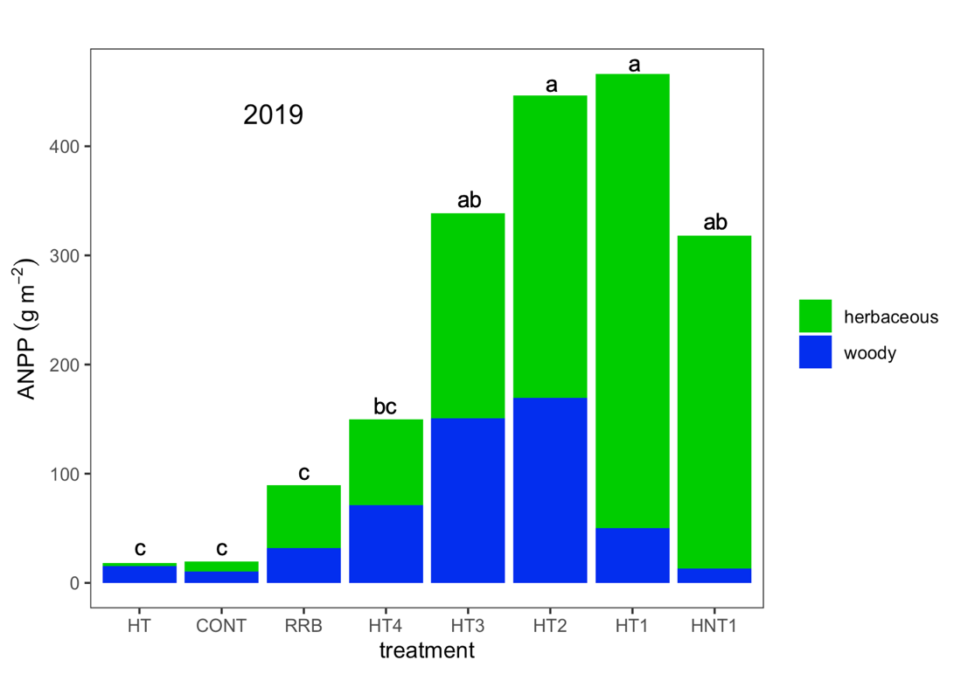

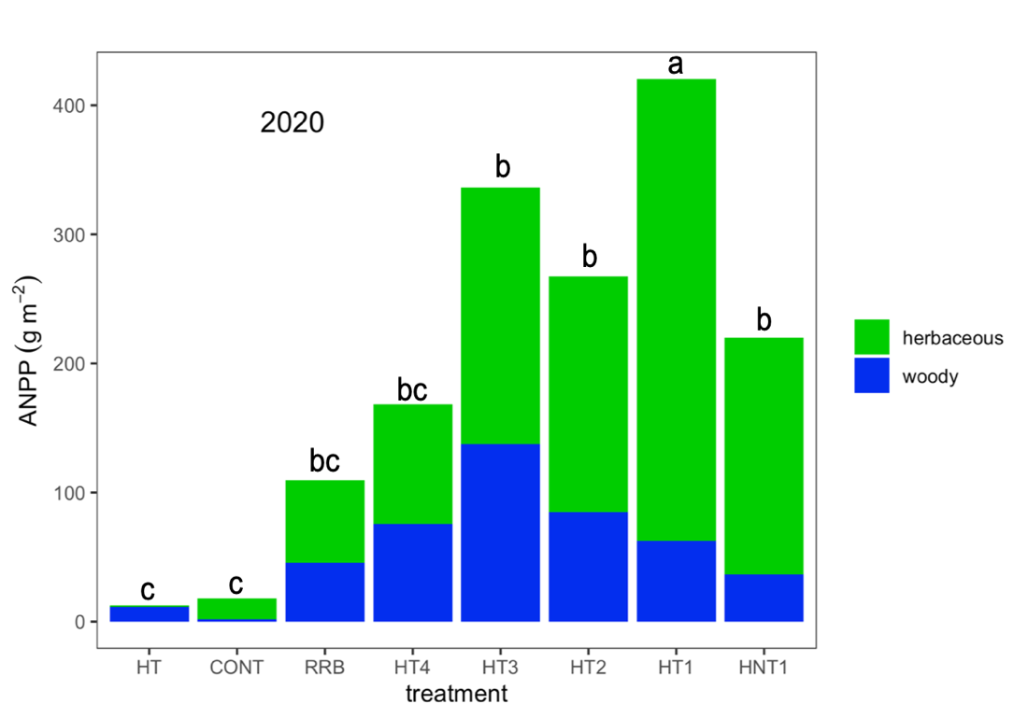

**Figure 1** Herbaceous and understory woody aboveground net primary production (ANPP) for eight treatments on the FHRA in 2019 and 2020. Within each year, letters indicate significant differences based on total ANPP (woody + herbaceous) at p < 0.05. See Table 1 for definition of treatments.

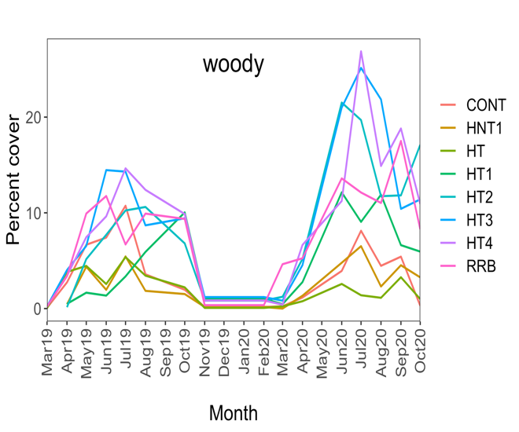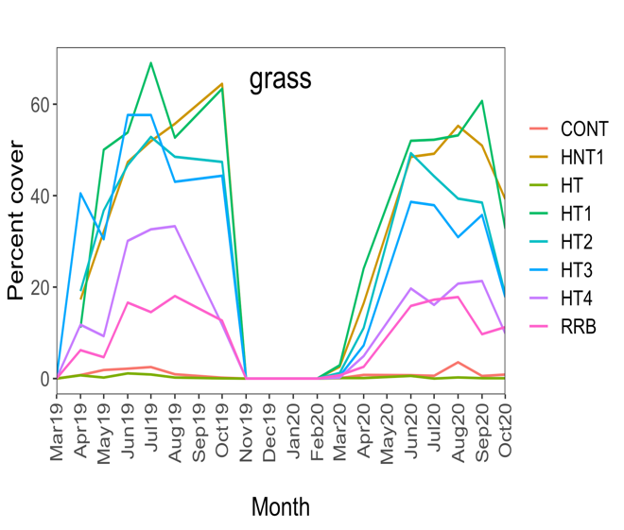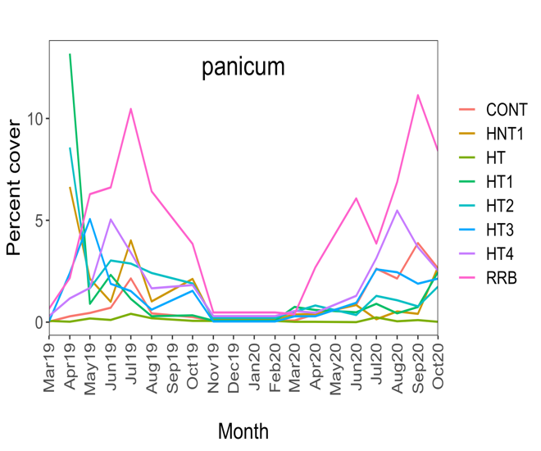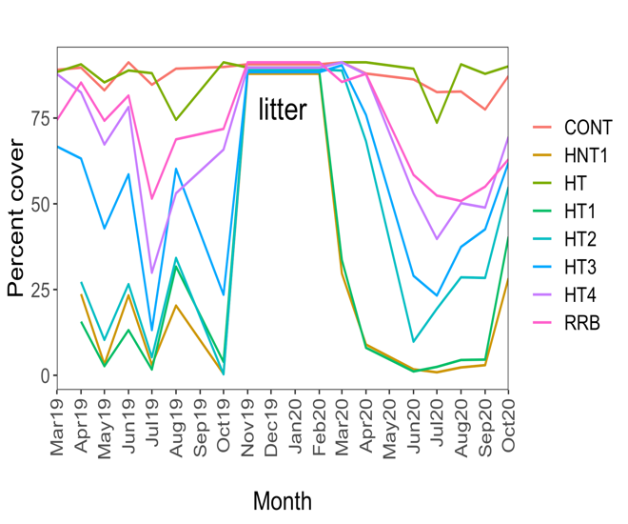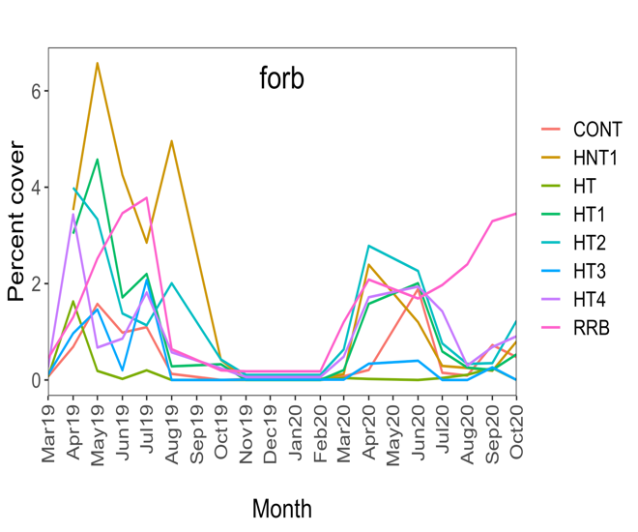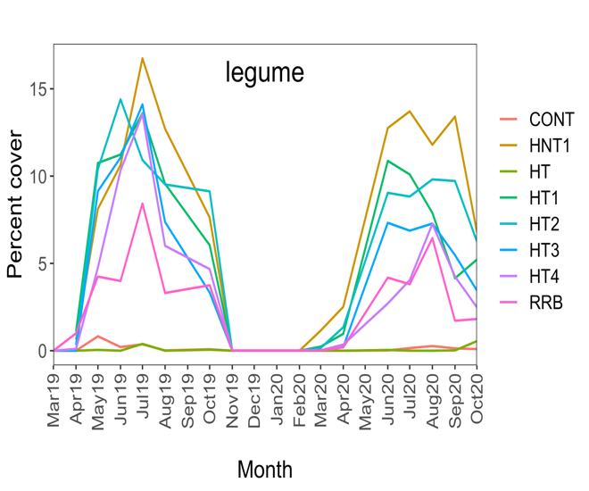

**Figure 2** Changes in plant functional group coverage (%) during the 2019 and 2020 growing seasons for the eight sampled treatments at the FHRA. See Table 1 for definition of treatments

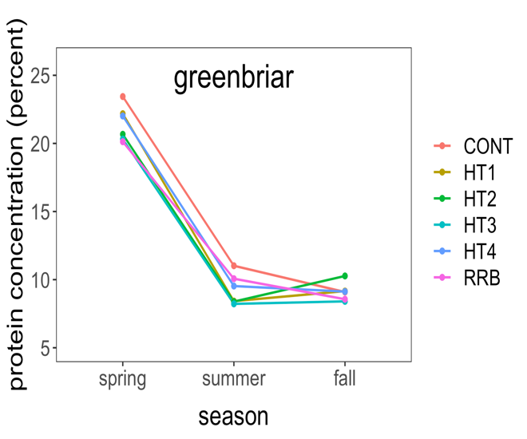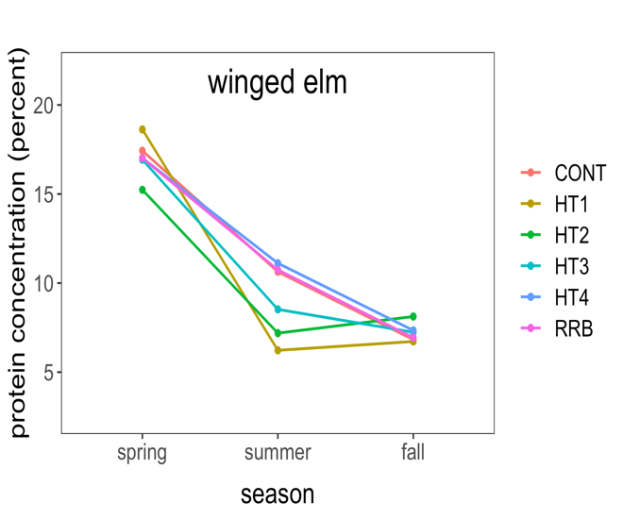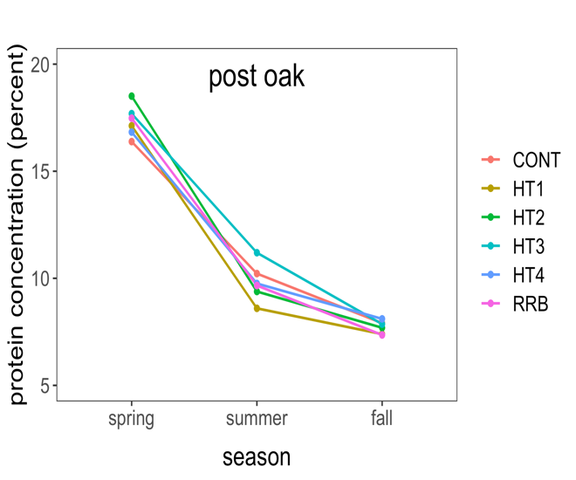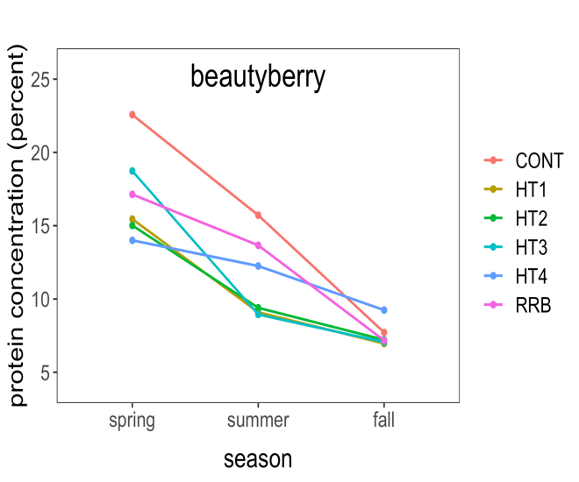

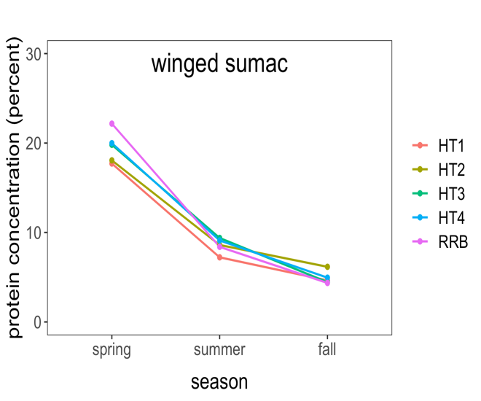





**Figure 3** Crude protein concentration for woody species throughout the 2020 growing season at the FHRA. See Table 1 for definition of treatments.

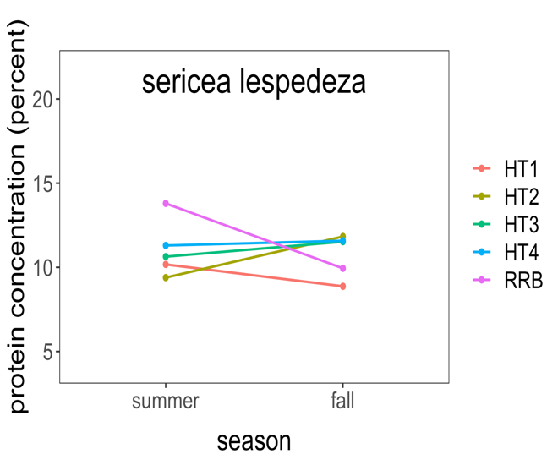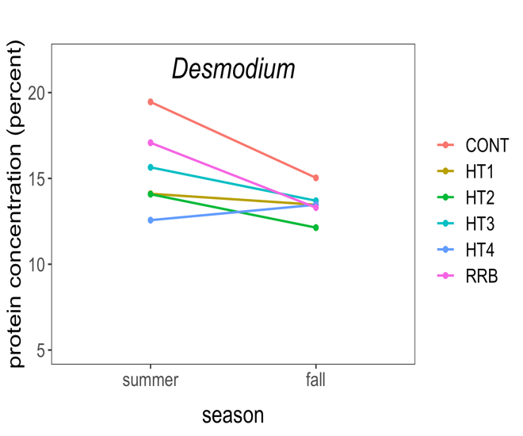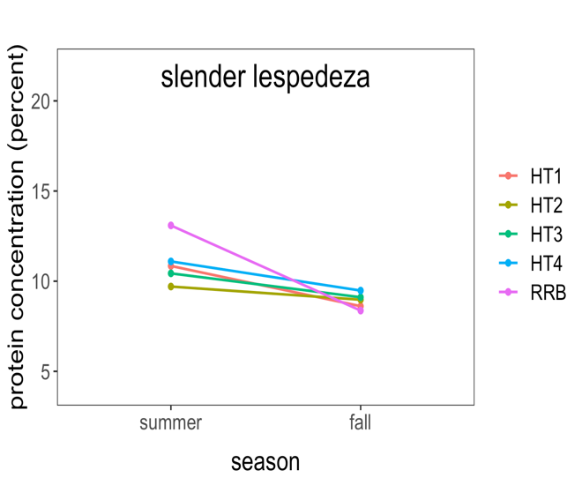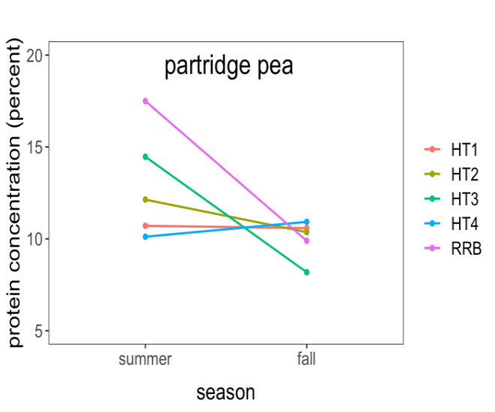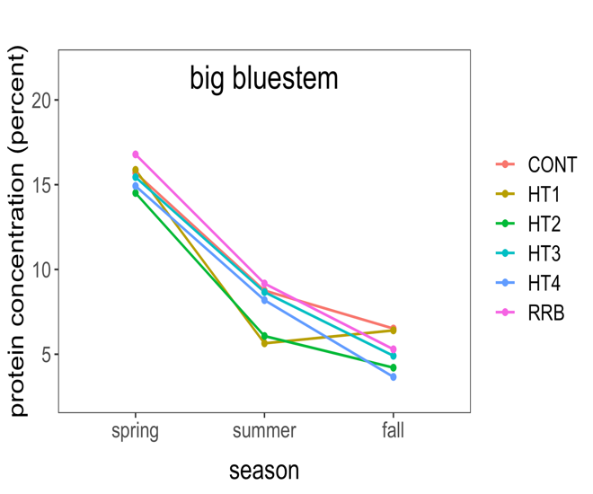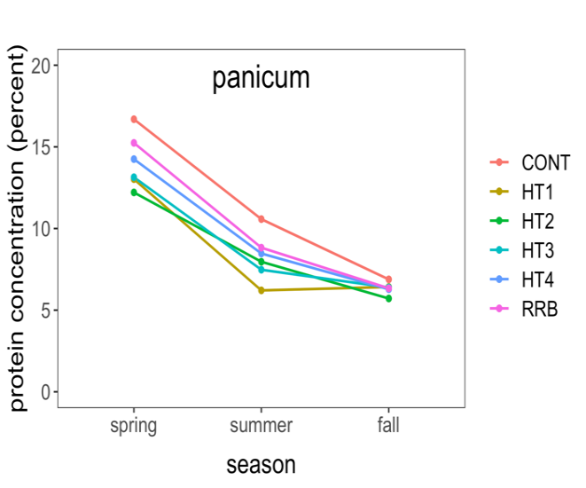**Figure 4** Crude protein concentration for herbaceous plants throughout the 2020 growing season at the FHRA. Big bluestem and panicum are grasses and sericea lespedeza, *Desmodium* spp. slender lespedeza and partridge pea are legumes. See Table 1 for definition of treatments.